iMonitor Keylogger Pro User Manual

1.Installation Guide 2
1.1.Sign up an account 2
1.2.Login Account 2
1.3.Download the Agent software 3
1.4.Antivirus software configuration 3
1.5.Install the Agent software 4
1.6.Start monitoring 4
2. Uninstallation Guide 5
3. Monitoring scene photo 6
4. FAQ 7

1.Installation Guide

1.1.Sign up an account：

http://www.imonitorsoft.com/anywheremonitor-signup.html

（Please use an E-mail address to sign up as the account ID.）

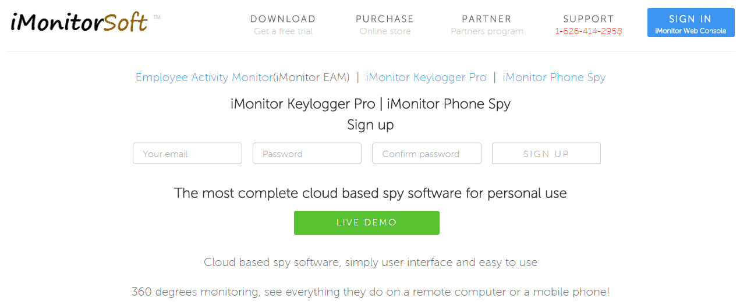

1.2.Login Account： http://www.imonitorsoft.com/anywheremonitor-signin.html

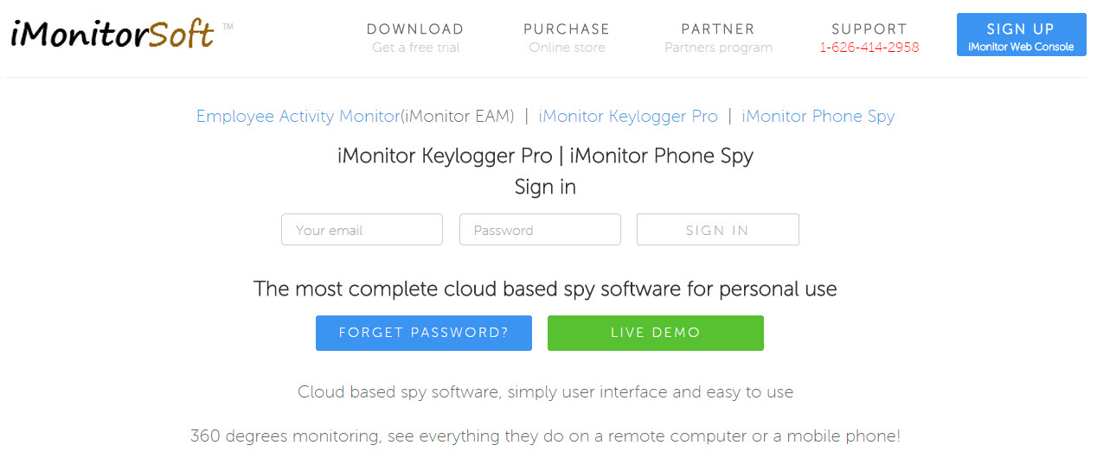

1.3.Download agent program：
（1）Open the browser on the monitored computer;
（2）Log in iMonitor Web Console with your account ID and password;
（3）Click “Home”-> “Add Windows Computer”, click on the blue text of “iMonitor Keylogger Pro Agent (download))” to download the Agent software.
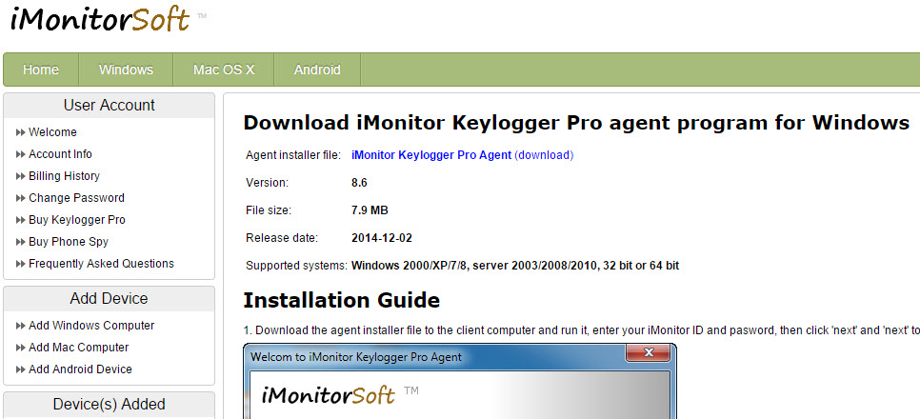

1.4.Antivirus software configuration： Add Agent program installation folder and the main program file path into the exclusion list of the anti-virus software . The path of Agent installation folder is "C:/Windows/system/sys/syscon", The main program file path is "C:/Windows/system/sys/syscon/mssys.exe". If the Agent program has been banned by anti-virus software, please re-install the Agent software.

1.5.Install the Agent software：Download the Agent installer onto the computer which you want to monitor, run it, input your account ID and password to complete the installation.
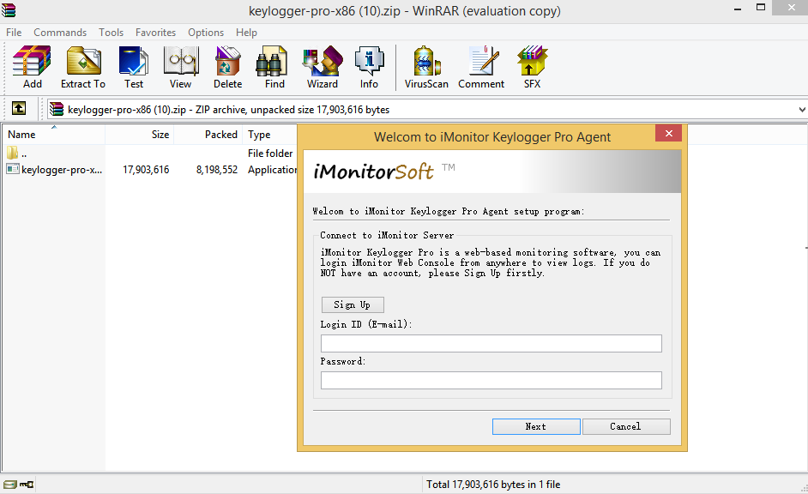1.6.Start monitoring：

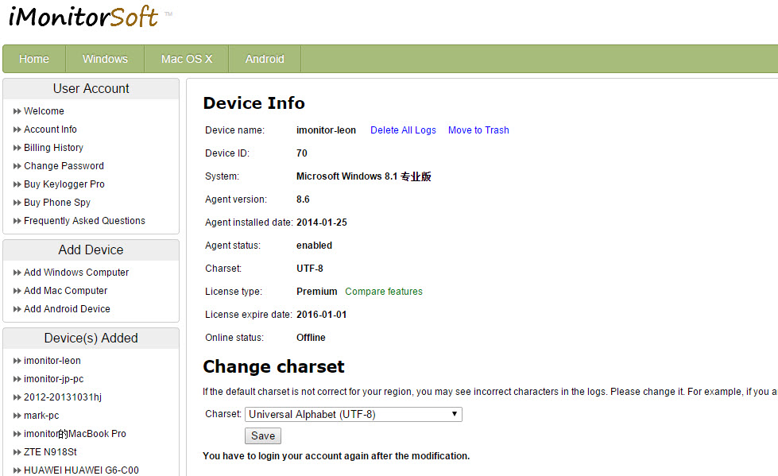

If you still have doubts in installing the client program, please contact us through the following ways:

Phone number: 1-626-414-2958

Skype ID: imonitor.support

Support: support@imonitorsoft.com

- Uninstallation Guide
If you want to uninstall the installed client program , please run the client installation program again on the monitored computer, then the installation program will show you the option to uninstall as below. Uninstallation is protected with password, you must enter the correct account password to uninstall.

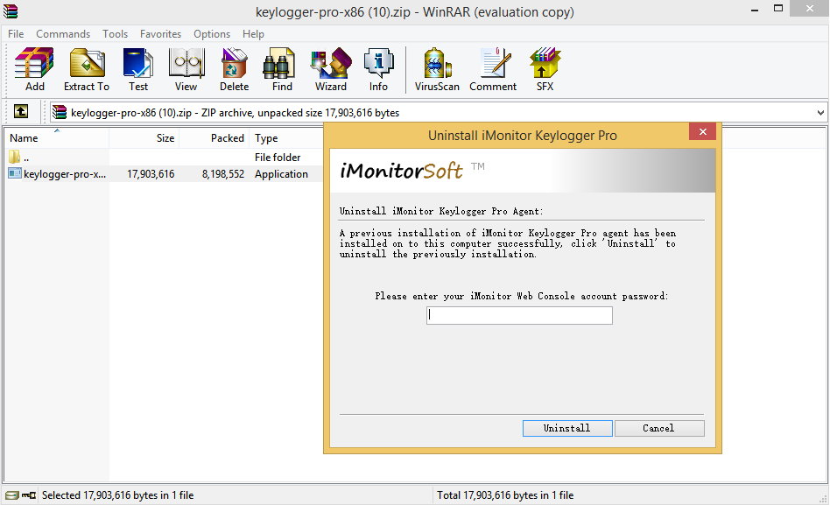

- Monitoring scene photo
Easy to use. Whether you're in the office or at home, or taking a public transport, you will be able to monitor the devices that you want to monitor as long as your computer or mobile phone can connect to the internet. The monitored devices can be a computer (including Windows and Mac), an Android phone or a tablet.
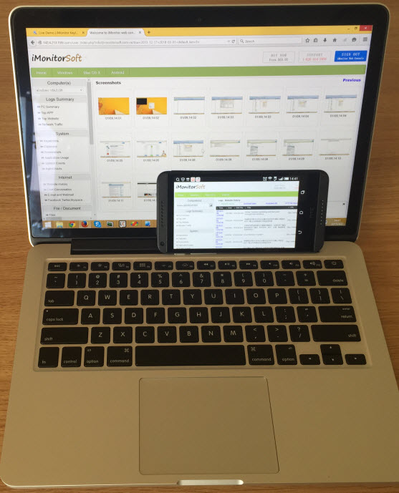
- FAQ
（1）I do not know how to install the iMonitor Keylogger Pro agent program,can you help me to install it?
If you have purchased a license, we can help you to install the iMonitor agent program via remote desktop tool, please feel free to contact us.

（2）How many days can I use iMonitor Keylogger Pro for free and is there any functional limitations?
We provide 3 days free trial and there is no functional limitations.

（3）If I buy a license, how many computer/device I can monitor with iMonitor Keylogger Pro?
One license for 1 computer/device, you need to buy another license to monitor another computer/device.

（4）How many days the logs will be stored on the server? Any limitation for data size?
15 days. If you want to extend the time, please contact us. No data size limitation.

（5）Anti-spyware or Antivirus software prevents me from installing iMonitor Keylogger Pro Agent.

You may add paths of the client program installation folder and the main program file into the exceptions list or trusted list.of anti-virus software . The path of client installation folder is "C:/Windows/system/sys /syscon", The path of client main program is "C:/Windows/system/sys/syscon/mssys.exe". If the client program has been banned by anti-virus software, please re-install the client software.

（6）Is the agent program running in stealth mode, will the user find it?
Yes, iMonitor Keylogger Pro agent program works in totally stealth mode, and protected by your iMonitor Web Console account password no message and window will popup, and no one can end it but you.

（7）How long is the synchronizatio interval?
Commonly it is 1-2 minutes, but due to internet connection situation it might be postponed sometimes.

